MVC:  
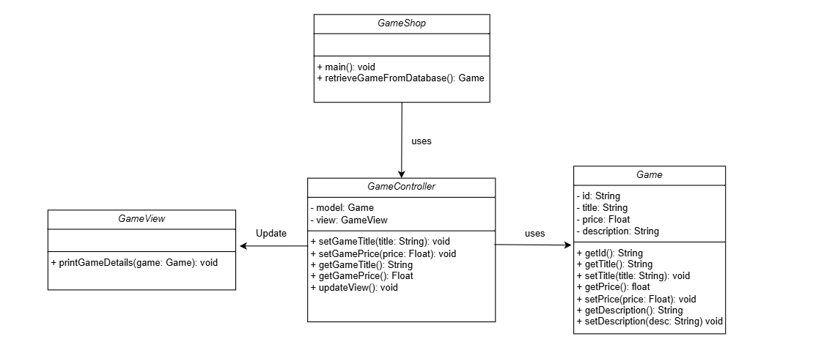

Class Diagram:

ER Diagram:

